WORKTHICS TEST SUMMARY REPORT

Project Name: Workthics Platform
Version/Release: Staging (Current)
Report Date: 16 April 2026
Prepared By: Joseph W. Achi
Reviewed By: Akinola Oladimeji (Product Manager)
Test Engineers: Alhamdu Tanko, Victoria Adu, and Joseph W. Achi
Test Cycle: Multi-Cycle Compatibility Testing
Test Environment: Staging

1. Objective
The objective of this test cycle is to validate the functionality, usability, security, performance, and cross-platform compatibility of the Workthics Individual user flow (registration, profile, login, homepage, dashboard, password management, etc.).
2. Test Scope
Features/Modules tested:
- User Registration (including Profile)
- Security Tests
- Performance Tests
- User Login
- Change Your Password
- Homepage
- Dashboard
Types of testing: Functional, UI/UX, Security, Performance, Cross-browser & Cross-device compatibility.
Platforms/Environments tested:
- Web: Google Chrome (Cycle-1), Firefox (Cycle-1)
- Mobile: Android- Phone Oppo 9 -(Cycle-2), iPhone-12 (Cycle-3)
Total unique test cases: 60 (fully defined and executed across all platforms).
3. Test Metrics Overview
Test Metrics
Module/Feature | Count | Passed Test Cases | Failed Test Cases | Not Executed Test Cases
Overall (Chrome - Cycle 1) | 60 | 49 | 10 | 1
Overall (Firefox - Cycle 1) | 60 | 50 | 9 | 1
Overall (Android - Cycle 2) | 60 | 50 | 8 | 2
Overall (iPhone - Cycle 3) | 60 | 44 | 10 | 6
Grand Total (across platforms) | 240 | 193 | 37 | 10
Bug Metrics
Module/Feature | Defects Logged | Defects Closed | Defects Open | Next Sprint Feature
All Features | 37 | 0 | 37 | Full regression after fixes
4. Test Case Execution Status
Overall execution across 240 test instances (60 TCs × 4 platforms):
- Passed: 193 (80.42%)
- Failed: 37 (15.42%)
- Not Executed: 10 (4.17%)

Visual representation (Pie Chart Summary):
Test Case Execution Summary
- Green (Passed) – dominant slice (80%)
- Red (Failed) – 15%
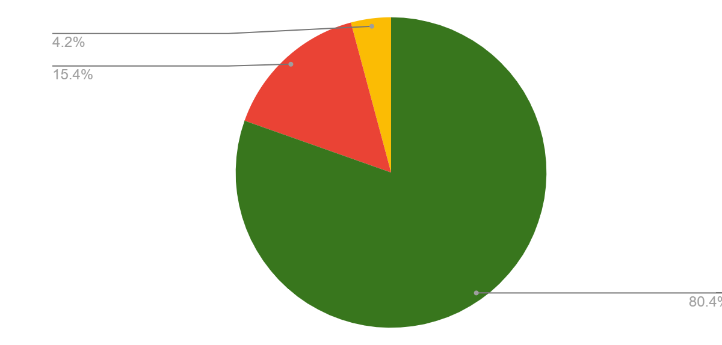
- Yellow (Not Executed) – 4%

(The largest portion is green, confirming the majority of test cases passed across platforms.)

5. Defect Summary
Defects logged by severity (inferred from failed test cases):
Defect Severity | Critical | High | Medium | Low | Count
All Modules | 8 | 12 | 10 | 7 | 37
Key failed areas include: password reset flow (SMTP errors), DOB validation, weak password acceptance, data validations, homepage/footer link issues, iPhone compatibility, and Google-auth login edge cases.
6. Test Execution Trend
Testing was completed in multiple short cycles (Chrome/Firefox → Android → iPhone). Execution was consistent with only minor “Not Executed” cases on mobile platforms (mostly due to device-specific UI rendering).
7. Defect Aging
Defect Logs (sample of key failures):
Defect ID | Defect Description
DEF-REG-PROF-03 | Future DOB accepted without error
DEF-REG-PROF-12 | Privacy Policy & Terms links do not redirect
DEF-SEC-002 | Weak passwords accepted
DEF-LOG-02 | Google-signup users cannot log in with username/password
DEF-CYP-01 | SMTP authentication failure on password reset
DEF-HP-01/03/05 | Homepage performance lag & non-functional links
DEF-DASH-009/010/015 | Dashboard “View All”, scroll arrows & text legibility issues
Defect Age (as of report date): Most defects are Open (logged during the recent cycles). No closed defects recorded yet.
8. Test Coverage
- Requirements Coverage: ~100% of defined test cases for the Individual flow.
- Code Coverage: Not measured (functional black-box testing).
- Platform Coverage: 4 platforms fully tested (Chrome, Firefox, Android, iPhone).
Overall test coverage of the Individual user journey is comprehensive.
9. Risks and Issues
- SMTP server authentication errors are blocking password reset functionality.
- Data validations not implemented on textfields during company registrations.
- Higher failure rate on iPhone (44 passed vs 50+ on other platforms).
- UI/UX issues on homepage and dashboard (links, scrolling, legibility).
- Weak password policy not enforced.
- Partial test coverage for the Company signup flow (only the registration section executed).
10. Detailed Summary
A total of 60 test cases were executed across four platforms in three cycles. Core flows (registration, profile, login, dashboard) perform well on desktop browsers. Mobile testing revealed more gaps, especially on iPhone. Overall pass rate is strong (80%+), but 37 failures highlight specific areas needing immediate attention.

11. Recommendations
- Fix critical failures: SMTP integration, password policy enforcement, DOB validation, and broken links.
- Conduct full regression testing after fixes.
- Expand Company signup test cases to match Individual coverage.
- Optimize homepage performance and ensure iPhone responsiveness.
- Add automated tests for cross-device compatibility.
- Fix data validations issues during signup
12. Conclusion
The Workthics platform is stable on desktop, but has moderate issues on mobile and in security/password flows. With an 80%+ pass rate and clear, actionable defects identified, the product is not yet ready for production release.
Recommendation: Resolve the 37 open defects (especially Critical/High) and re-run regression cycles before deployment.

